BSSC 2020 Australian-German Cultural Exchange Trip
Departure: last week in November 2020
Expression of Interest Form
Travel through German speaking countries in Central Europe and experience an exchange in Germany - approx. 20 days of travel

This trip/exchange is open to language students and non-language students! You don’t need to be studying German to come along.
Return this form by Friday 6th March to Kristina Dean in the Language Centre Staffroom. Please get your parent/guardian signature and advisor signature. Note that full trip permission documentation and parent/guardian approval will be required once we have confirmed names of participating students.

If you have any questions about the trip or application process please contact:
Kristina Dean (German Teacher) - dean.kristina@bssc.edu.au

1 - PERSONAL DETAILS
BSSC Student ID: ___________ First name: _____________________ Family name: ______________________
Advisor Group: ________ DOB: _____________ Year: 11 12 Past school: ________________________
Passport expiry date: _________________ Note: If you need to apply for a passport you will need to do this ASAP.

2 - HOSTING A GERMAN STUDENT
To provide a reciprocal relationship between sister schools, the best possible outcome is for families to host back a German student during the period of July-August of the following year, for 5 weeks.

Yes, we are able to host a student for 5 weeks.
No - Please explain: _________________________________________________________________________
_______________________________________________ Signature of parent(s): _________________________

3 - GETTING TO KNOW YOU
Please rate yourself using the 5 point scale of Strongly Agree (SA), Agree (A), Neutral (N), Disagree (D), Strongly Disagree (SD) against each of the statements and get your Advisor to sign this form.

Attitude and Behaviour is in line with our college values SA A N D SD
Would be a good ambassador for Bendigo and our college SA A N D SD
Gets along well with others SA A N D SD
Follows instructions well SA A N D SD
Comes to school prepared for classes and activities SA A N D SD

Tell us why you wish to participate and what you hope to get out of a trip to Germany.
_____________________________________________________________________________________________
_____________________________________________________________________________________________
Signature of student: ________________________________
Advisor Name: _____________________________ Advisor Signature: _______________________________
Advisor comments: ____________________________________________________________________________
4 - Parent permission
I give permission for my child to apply for the Dec/Jan Germany Trip. I understand that if my child is accepted, I will need to cover the cost of a passport and trip costs of $4,000 (exact cost to be confirmed by end of semester 1) - with a non-refundable payment of $500 due Monday 16th March, and another 5 payments of $700 due Friday 27th March, Friday 17th April, Friday 30th April, Friday 8th May and finally Friday 25th May.

Parent Name: ___________________________ Signature: _________________________ Date: ______________

Please tick preferred option (A, B or C) and indicate which country you would like to stay in for the host family/immersion part of the trip.
Refer to page 3 of this document.

GERMANY

OPTION A
OPTION B
OPTION C

Office Use only: Application submitted to: ___________________________ Date: ___________________ Time: ___________

PAYMENT DETAILS - PLEASE KEEP THIS PAGE
PAYMENTS
$500 due Monday 16th March 2020 - NON-REFUNDABLE deposit
$700 due Friday 27th March 2020
$700 due Friday 17th April 2020
$700 due Friday 30th April 2020
$700 due Friday 8th May 2020
$700 due Friday 25th May 2020

How to make payments?
Go to the Finance Office
Or
Bank Transfer
You must include student surname and description (Example: SMITH GER/FR)
Bank: Commonwealth Bank
Account name: BSSC official account
BSB: 063-506
Account Number: 907 295

Any questions?
Contact Kristina (dean.kristina@bssc.edu.au)
Next meeting?
Mid-Term 2, date to be confirmed. You will be emailed directly once the date/location have been confirmed.
Do you have a passport?
Yes - check that it will still be valid for another 6 months after returned date.
No - apply ASAP as we will need passports to purchase plane tickets (early June).
Trip Overview
Departure approx. 30th of November 2020 Return: 16th December 2020 or 15th Jan 2021

Part 1 - Cultural and historical visits in Switzerland, Austria and Germany – 8 to 10 days.
Day 1 - Flight to Zurich.
Days 2 and 3 - Zurich, Switzerland - Walking tour of old city of Zurich, visit of Zurich Christmas market, day trip to Luzern and Engelberg/Mount Titlis (Swiss Alps)
Days 4 – Liechtenstein, Vaduz
Days 5- 6 Salzburg, Austria – City walking tour, Fortress, Castle and Cathedral and visit the Saltmines
Days 7 to 9- Munich, Germany - City walking tour, including 3rd Reich history, visit of Dachau concentration camp memorial, Munich Christmas market and a day tour to the Schloss Neuschwanstein.

Part 2 - Homestay in Stockach (Germany).
Days 9 to 17 (or longer if choosing option B) - Homestay - Students to stay in a German host family and go the local high school.

Option A
- Available to both language and non-language students.
- Stay in host family from day 9 to day 17, return to Australia before Christmas with teacher.
- You don’t have to speak the language to manage in a German host families - you will be sent to a family that can speak English.
Option B
- Only available to language students. Highly recommended if you are studying VCE German.
- Stay in host family over the Christmas holidays and return as a group (without teacher) mid-January.
Option C
- Only available to German language students. Pick up at Zürich airport by host family - homestay only, 7 weeks.

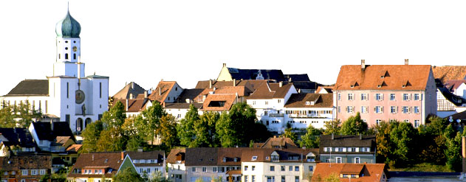
Options A and B both cost $4,000. Option C only cost about $2,500 (Airfare and travel insurance).
Stockach, Germany

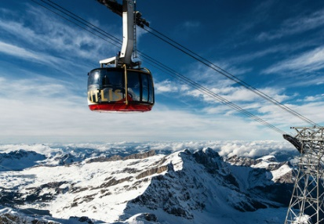
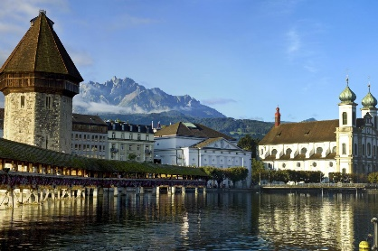
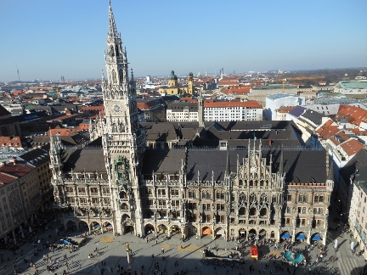
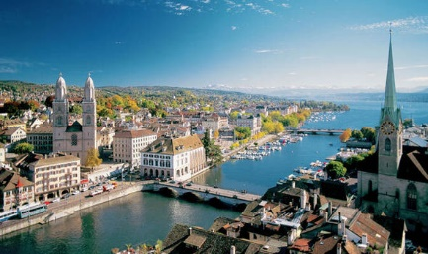
Munich
Salzburg
Zurich, Mount Titlis, Luzern

