BSSC 2018 Australian-Chinese Cultural Exchange trip (9-22 April)
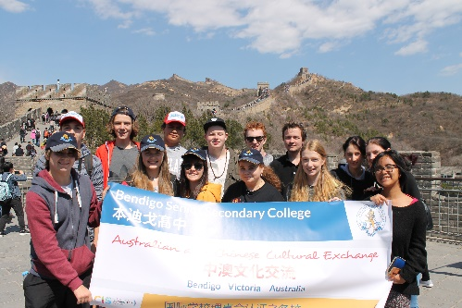
Application Form

Your application for this trip is due on Tuesday 20 February at lunchtime. Please get your parent signature over the weekend and Advisor signature at the Group meeting on Monday morning. You need to bring this to the ‘trip confirmation’ meeting in the L1 Language Centre room please. If you have any questions about the trip or application process please contact Linda Lyons via email lyons.linda@bssc.edu.au and June Featherstone featherstone.june@bssc.edu.au. Please note that full trip permission documentation and parent approval will be required once we have confirmed names of participating students.
BSSC Student ID: ___________ First name: _____________________ Family name: ___________________________
Advisor Group: ________ DOB: _____________ Year: 11 12 Past school: ______________________
Tell us why you wish to participate and what you hope to get out of a trip to China.
__________________________________________________________________________________________________
__________________________________________________________________________________________________
__________________________________________________________________________________________________
__________________________________________________________________________________________________
__________________________________________________________________________________________________
_______________________________________________________________ Signature: _________________________
Passport expiry date: _________ Note: If you need to apply for a passport you will need to do this ‘NOW’.
Please rate yourself using the 5 point scale of Strongly Agree (SA), Agree (A), Neutral (N), Disagree (D), Strongly Disagree (SD) against each of the statements and get your Advisor to sign this form.
Attitude and Behaviour is in line with our college values SA A N D SD
Would be a good ambassador for Bendigo and our college SA A N D SD
Gets along well with others SA A N D SD
Follows instructions well SA A N D SD
Comes to school prepared for classes and activities SA A N D SD

Advisor Name: ________________________________ Advisor Signature: _________________________________
Advisor comments: __________________________________________________________________________________
___________________________________________________________________________________________________
Parent permission
I give permission for my child to apply for the April China trip. I understand that if my child is accepted, I will need to cover the cost of a passport, any immunisations and China trip costs of $2500-$2700 - with a payment of $1000 due by 20th February and remaining payments due by Tuesday 27th March.
Parent Name: ________________________________ Signature: _________________________ Date: ______________
………………………………………………………………………………………………………………………………………………………………………………………….

Office Use only: Application submitted to: _______________________________ Date: _____________________ Time: ___________

